Technical Design I
Contents
- Introduction
- Technology Stack
  - Language and Frameworks
  - Web Application Templating Engine
  - Authentication and Authorisation
  - Database Transactions
- Technical Design
  - Authentication and Authorisation
  - Orders
  - Reports
  - Stock Value Generator
- References

Introduction
The aim of this document is to provide a technical design option with which to implement the product proposed by the FDM05 Project Brief. An alternative technical design is provided in Technical Design II. The requirements of the project have been de-constructed to help produce the technical designs. Additionally, the design goals described in FDM05 – Design Goals were used as guidelines through the design process.
The requirements cover functionality common to many web applications that handle monetary transactions. For instance, shopping websites persist users' shopping carts, whether through a session using cookies, or by associating the cart with the user's account. To perform the latter, these websites require user registration. This, alongside the necessity to sell their items, requires database transactions. Additionally, stock-related websites, whether they are designed to provide stock news or to broker stocks, provide live updates of stock information.
The actual process of storing credit card information against a user is typically done through a payment gateway, such as PayPal or Authorize.Net. In real-life business situations, these payment gateways would handle authentication and security. It is far easier and avoids many risks, e.g. card fraud, database hacking, privilege abuse (Solomon, 2014) to allow such third-parties to handle credit card information and rely on them to abide by PCI standards (PCI Security Standards Council, 2016). As the product is a simulation and the project requirements specifically state how credit card information should be stored in the database, this design will not consider PCI standards within the scope of the project.
Given that these are often implemented functionalities, there already exist design goals and frameworks covering boilerplate code. It is not only beneficial to use established frameworks, to save time tackling already solved problems, but it is in the interest of security to abide by such standards. These were considered when designing the differing pieces of functionality and their explanations can be found in the document.

Technology Stack
The implementation of the stock trading simulator will expand on the technologies used in the first project which used known standards for web applications.

Language and Frameworks
Firstly, Java was used to implement the API in the former project. C# was also considered, utilising its ASP.NET MVC framework. The documentation that Microsoft provide for C# (Microsoft, 2007) provides a significant amount of guidance on following SOLID principles, and the 4 Pillars, and following these ensures ease of extensibility and code that can be better unit tested.
However, these solve the same problems as Java with Spring Boot which have already been practised in the previous project, which would be quicker to implement due to its familiarity. For instance, Java, also an OOP language (Gosling et al., 2014) encourages 4-Pillar principles. Spring, similar to ASP.NET, also guides a programmer to use loose coupling through inversion of control and dependency injection by autowiring.
In a sense, Spring Boot has an advantage over ASP.NET MVC in that it covers a series of boilerplate code and features by default. This means that within its core dependencies, it sets a standard as to how a programmer should connect to a database (Spring ORM), send a REST request (such as by the RestTemplate class), or perform validation. ASP.NET is able to provide the same capabilities through a number of frameworks but typically does not provide a default. The more opinionated nature of Spring therefore helps the developer follow appropriate standards.
The project requirements have stated that the server will ideally send information to the client to provide a live stream of stock data. This can be done by technologies such as Server-Send Events or websockets. The former requires the client to create listeners for events sent by the server while the latter opens a constant connection for data to be sent to and from the client. As the need is only to send data from server to client, SSE is chosen as the push technology.
Ajax will also be employed, as specified by the project requirements, to send requests for data. The application will provide paginated stock information and the user will be able to request separate pages through asynchronous calls to the server.

Web Application Templating Engine
As required by the project brief, AJAX will be used to provide a live stream of stock data to the users. This will be used with HTML, CSS, and JavaScript, leaving the last web interface technology to consider the view technology. Thymeleaf and FreeMarker are both supported by Spring and FreeMarker was chosen in the previous project to use as the templating engine, and will also be used. This choice can seem contrary to the above argument to use 'default' technologies as Thymeleaf is supported by Spring by default. However, Thymeleaf shows comparably slow performance compared to FreeMarker without providing many benefits (Wozniak, 2016).

Authentication and Authorisation
There are essentially three kinds of users to the real-time stock trading simulator:
- Casual users viewing the website
- Users with accounts who wish to perform transactions
- Admin users who require an interface to manage user and company accounts
No authentication is required in the first regard. However, authentication is required for the second two types, and authorisation to distinguish between them. It is particularly important that existing standards and implementations should be used for security as these are implementations that have been tried and tested. Additionally, should the usage of such technologies be breached for any reason, their wide-usage will highlight the problem so that it can be tackled as soon as possible.
To implement authentication and authorisation, Spring provides Spring Security that not only covers boiler plate but also provides standards with which to:
- Persist users against a database (via UserDetailsService)
- Authenticate (via AuthenticationManagerBuilder)
- Authorisation (via GrantedAuthority)
- Encryption (via PasswordEncoder)
In addition to Spring Security, there are two other major security models. JAAS is Java's own Java Authentication and Authorization Service. This provides basic features such as the LoginModule, which manages the authentication of a user, but is not as opinionated as Spring Security. In the interest of following clear and guided standards, Spring Security is chosen over JAAS for this reason.
Shiro is another security model, whose aim it is to be a security framework that is as simple to understand as possible. However, Spring Security has more tutorials available for its implementation so appears to have an easier learning curve. Additionally, both Shiro and Spring Security share features but Shiro requires additional integration so Spring Security was thought to be the better choice.

Database Transactions
MySQL will be used as the RDBMS to reiterate earlier points on wide-spread usage, pervasive number of tutorials, and familiarity. Given that the Spring Security classes above utilise Spring Data, this design will follow its usage. Specifically, Spring Data JPA (Java Persistence API) will allow us to specify repository interfaces and data sources without having to create concrete DAO (Data Access Object) classes.
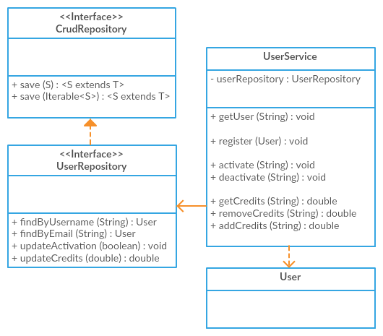
Figure 1, UserService and UserRepository class diagramme
Service objects will be used to access and create domain objects. For instance, the above shows the UserService using a UserRepository to handle User entities. The UserRepository extends the CrudRepository interface provided by Spring Data JPA. The addition of method signatures in the UserRepository enables Spring to generate queries against the data source, avoiding boilerplate code.
Spring Data JPA is able to generate query for findbyUsername(String) by recognising the 'findBy' phrase and the variable name for the User. Other necessary methods can be implemented with the @Query annotation. The UserService will need to be able to activate a User account once the corresponding e-mail address has been validated. In order to do this, it will call the updateActivation(boolean) method which can be annotated as '@Query(“UPDATE user SET active=true WHERE username=?1”).
@Entity
public class User {
@Id
@GeneratedValue(strategy = GenerationType.AUTO)
private long id;
@Enumerated(EnumType.STRING)
private Role role;
private String username;
private String password;
private String email;
private String firstName;
private String lastName;
private LocalDateTime birthDate;
private double credits;
private boolean active;
protected User() {
}
public User(Role role, String username, String password, String email, String firstName, String lastName) {
this.role = role;
this.username = username;
this.password = password;
this.email = email;
this.firstName = firstName;
this.lastName = lastName;
}
// Setters and getters
}
Figure 2, User entity class example
Entity classes are identified by the @Entity annotation. This informs Spring Data JPA that the class relates to a data source object whose class variables map to table columns. The protected method is used by Spring Data JPA to initialise the class and setters are used to populate the class. The public method is then used by other classes, such as the UserService, to create the User which can be persisted via the CrudRepository's save(S) method.
In relying on Spring interfaces and annotations, the exposed DIT and NOC can often be kept at 1 and 0 respectively. This means much easier maintainability and ease of understanding to other developers. A developer who takes on the project need not understand multiple layers of architecture of the code base but rather require an understanding of the more universal framework of Spring.

Technical Design
Authentication and Authorisation

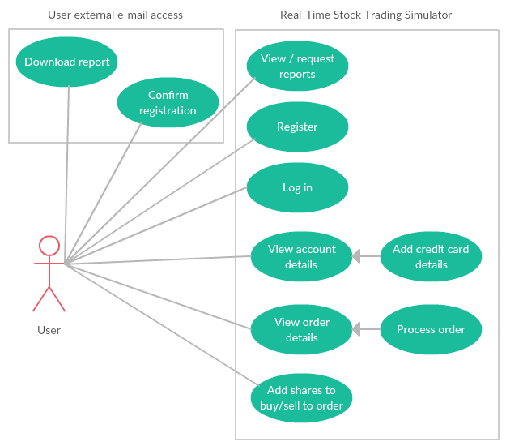
Figure 3, User use case
The design and implementation of the web application can be described as driven from the user needs and expectations. Primarily, the main features the user will wish to access are:
- Buying stocks
- Selling stocks
- Viewing reports
These features cover sensitive data such as credit card information and user transactional data. User authentication is therefore necessary to protect this information, in addition to providing convenient services such as user state persistence across sessions.

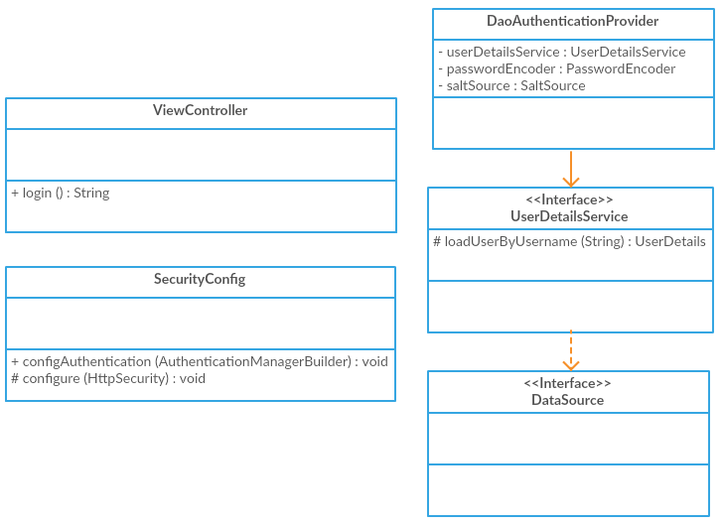
Figure 4, Security class diagramme
The implementation of user authentication and authorisation through Spring Security allows a simple authentication manager to be easily attached to the application due to its loose coupling. The above classes, excluding the ViewController are added to the MVC model. The ViewController, assumed to already be a part of the existing web application, is then configured to handle the login view.
If the page is secured, the user flow is as follows:
- User accesses page
- SecurityConfig checks the authority required to access the page
- If the user is not signed in, redirect to the login view
  - ViewController provides login form
- DaoAuthenticationProvider calls the UserDetailsService to retrieve UserDetails
- DaoAuthenticationProvider provides the authentication and authority of the user
- SecurityConfig continues or blocks the view flow accordingly
SecurityConfig can check the authorisation required for a given set of web pages through pattern matching. For instance, the configuration shown in Figure 5 allows CSS elements and the front page to be made available to any user. Pages from a parent link related to user-specific information, such as '/account' or '/reports' require authentication, as well as '/stocks' which can cover webpages required for purchasing and selling stocks. '/admin' can lead to a set of tools for an admin to perform tasks such as blocking users or adding new companies to the database.
@EnableWebSecurity
public class SecurityConfig extends WebSecurityConfigurerAdapter {
@Override
protected void configure(HttpSecurity http) throws Exception {
http
.authorizeRequests()
.antMatchers("/css/**", "/index").permitAll()
.antMatchers("/account/**").hasRole("USER")
.antMatchers("/stocks/**").hasRole("USER")
.antMatchers("/reports/**").hasRole("USER")
.antMatchers("/admin/**").hasRole("ADMIN")
.and()
.formLogin()
.loginPage("/login").failureUrl("/login-error");
}
}
Figure 5, SecurityConfig configuration
Using the standard Spring model, we can see a clear separation of concerns. All the security configuration is in a single file so should we wish to modify or add pages, only SecurityConfig is changed. The decoupling through the separation of concerns also provides great flexibility. For instance, should we change the type of data source only the DataSource bean needs to be changed.
Spring Security also allows the DaoAuthenticationProvider a PasswordEncoder that can be configured for encryption. To perform one-way password encryption, the BcryptPasswordEncoder can be easily autowired and the developer does not need to meddle with encryption algorithms. Similarly, two-way password encryption can be implemented in the same manner to implement credit card persistence for the user.

Orders
The broker is responsible for processing transactions. The OrderController passes orders, submitted by the user, to the OrderService. The OrderService’s responsibility is to send the Order to the Broker for processing – if successful, the OrderService records the Order – and finally returns the success state to the OrderController.
The Broker processes transactions by orchestrating the UserService, StockService, and UserStockService. The StockService provides access to live stock data, while the UserStockService provides access to user stock data.
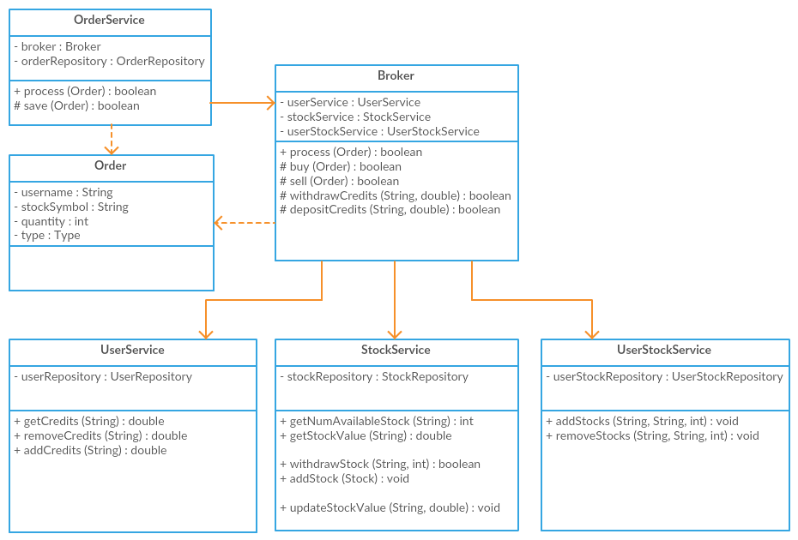
Figure 6, Broker class diagramme
Transactions rely on sufficient user credits and sufficient stocks being available. Between the time it takes to validate the order, these values may change. However, to prevent dependencies becoming invalid, locks can cause slowness to performance. Rather than using locks, we can make the transactions themselves dependent in a single step. Instead of validating and purchasing a number of stocks in two method calls, this can be done in a single method call that ultimately calls an SQL query to the effect of ‘UPDATE market SET quantity = quantity - ?2 WHERE symbol = ?1 AND quantity > ?2’. The validation is therefore incorporated into the transaction and prevents blocking calls to the database.
As an example, the flow to purchase stocks would then look like:
- Broker calls StockService to get stock value
- Broker calls UserService to withdraw user credits
- Broker calls StockService to withdraw stocks
- Broker calls UserStockService to add stocks against the user
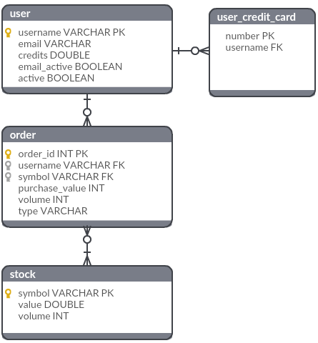
Figure 7, Order ERD
The separation of concerns reflects the maintainability through the WMC. For instance, if order processing and validation were included within the Broker, the WMC would be increased by at least 3 methods, e.g. save(..), validateUserCredits(..), validateStockQuantity(..).
Additionally, though Service classes are similar as they provide an access layer to the database, they are not similar enough to warrant an overarching interface or parent class. This is possible due to the Repository classes they use which cover database access. This implementation keeps the NOC at 0.

Reports
One of the necessary requirements is that the user must be able to download reports. These reports cover data regarding the user, stocks, and/or companies.
Report type | Data required
Shares owned by user | Users  Shares
Company stock details | Companies  Shares
Stock values | Shares
Table 1, Report types and data required
The reports therefore need access to different kinds of data from multiple tables. Rather than inserting the corresponding Repository interfaces as class variables, access is mediated through the Service classes so that access can be controlled.
Figure 7 shows how the necessary services are autowired into the POJO reports. These reports are lazy beans which are instantiated by the ReportInitialiser when the ReportService receives a ReportRequest. The ReportRequest contains a report name which is mapped to a bean name. Once the report is initialised, it will then use the injected services within its concrete executeReport(ReportRequest) method.

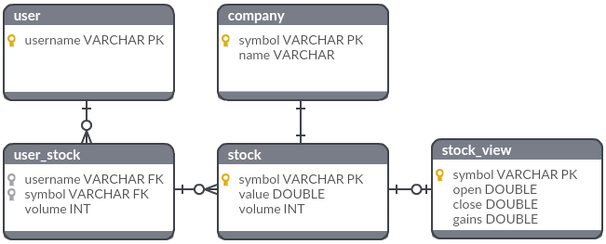
Figure 8, Report required tables ERD

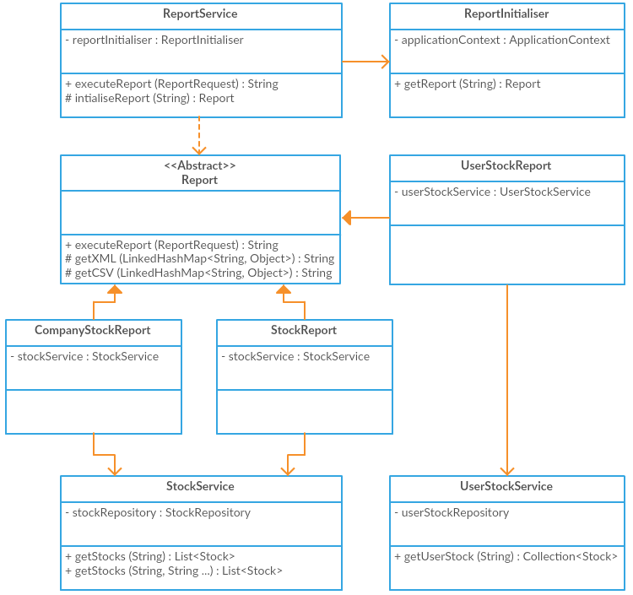
Figure 9, ReportService class diagramme

Stock Value Generator
The stock values of shares within the trading simulator will be generated separately by a stock value generator. This will be decoupled, following the single responsibility principle and dependency inversion principle from the trading simulator by use of the StockValueGenerator to StockUpdater.
Different implementations can be used for the simulator as needs change. The stock values as per the project requirements describe stock values being generated in a certain range, modulated by a given formula. Hypothetically, a concrete stock value generator implemented against real stocks could be used and plugged into the simulator due correct separation of concerns.
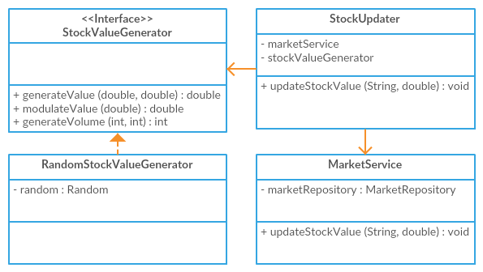
Figure 10, StockUpdater class diagramme
References
Gosling et al. (2014) The Java Language Specification, Java SE 8 Edition Oracle America, Inc.
Microsoft (2007) C# Guide [online], https://docs.microsoft.com/en-us/dotnet/articles/csharp/ (Accessed 11 April 2017)
PCI Security Standards Council (2016) PCI DSS Agreement [online], https://www.pcisecuritystandards.org/document_library?category=pcidss&document=pci_dss (Accessed 14 May 2017)
Solomon (2014) Your Database is NOT your Credit Card Vault. Here is why [online], https://www.chargebee.com/blog/db-credit-card-vault/ (Accessed 14 May 2017)
Wozniak (2016) Java: Benchmark Thymeleaf 2.1.4 vs Thymeleaf 3.0 SNAPSHOT [online], https://smarterco.de/java-benchmark-thymeleaf-2-1-4-vs-thymeleaf-3-0-snapshot/ (Accessed 11 April 2017)

